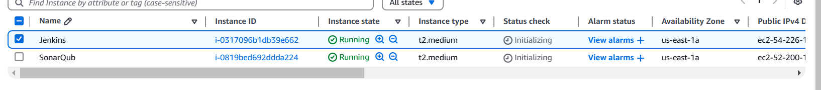

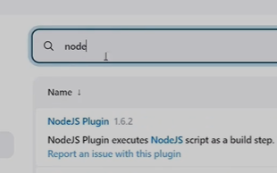

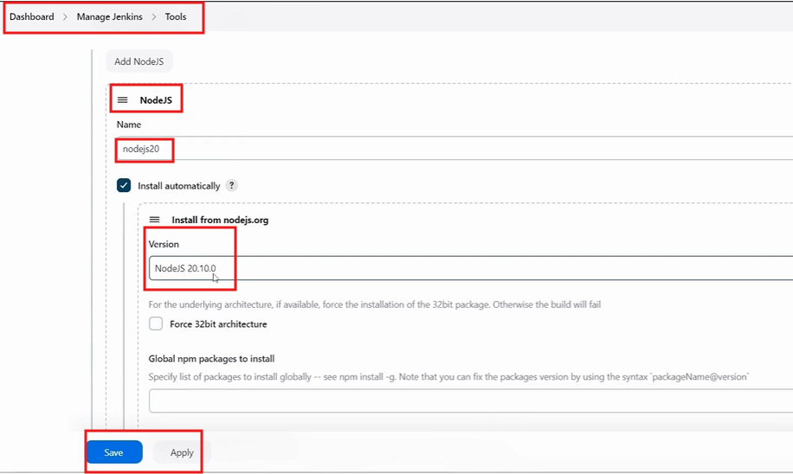

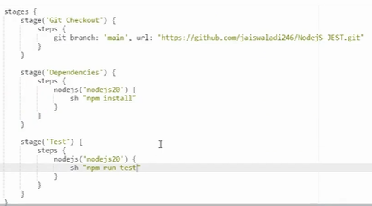



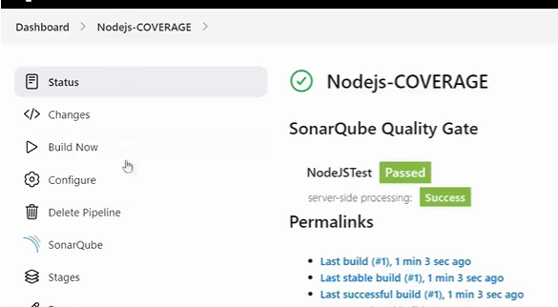

**Jenkins Code:**

pipeline {

agent any

environment {

SCANNER_HOME = tool 'sonar-scanner'

}

stages {

stage('git checkout') {

steps {

git branch: 'main', url: 'https://github.com/Jagan-18/NodeJS-JEST.git'

}

}

stage('Dependencies') {

steps {

nodejs('nodejs20') {

sh 'npm install'

}

}

}

stage('Tests') {

steps {

nodejs('nodejs20') {

sh 'npm run test'

}

}

}

stage('SonarQube Analysis') {

steps {

withSonarQubeEnv('sonar-server') {

sh '''

$SCANNER_HOME/bin/sonar-scanner -Dsonar.projectName=nodejstest \

-Dsonar.projectKey=nodejstest \

-Dsonar.sources=. -Dsonar.tests=. -Dsonar.test.inclusions=**/*.test.js \

-Dsonar.javascript.lcov.reportPaths=coverage/lcov.info

'''

}

}

}

}

}